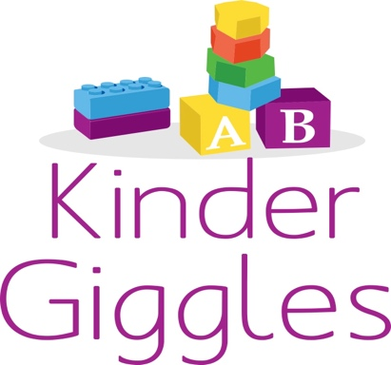
Summer Stay & Play Session

Summer Holidays
For children accessing funding on a ‘stretched offer’ please note they will be off for their Summer Break, week commencing 24th August, and will return on Tuesday 2nd September.
If you are unsure, the funded hours on your invoice will show as either 12 or 24 per week.
For children who attend all year round, please remember that Nursery will be closed for Bank Holiday Monday – 31st August.


Beyond Mama
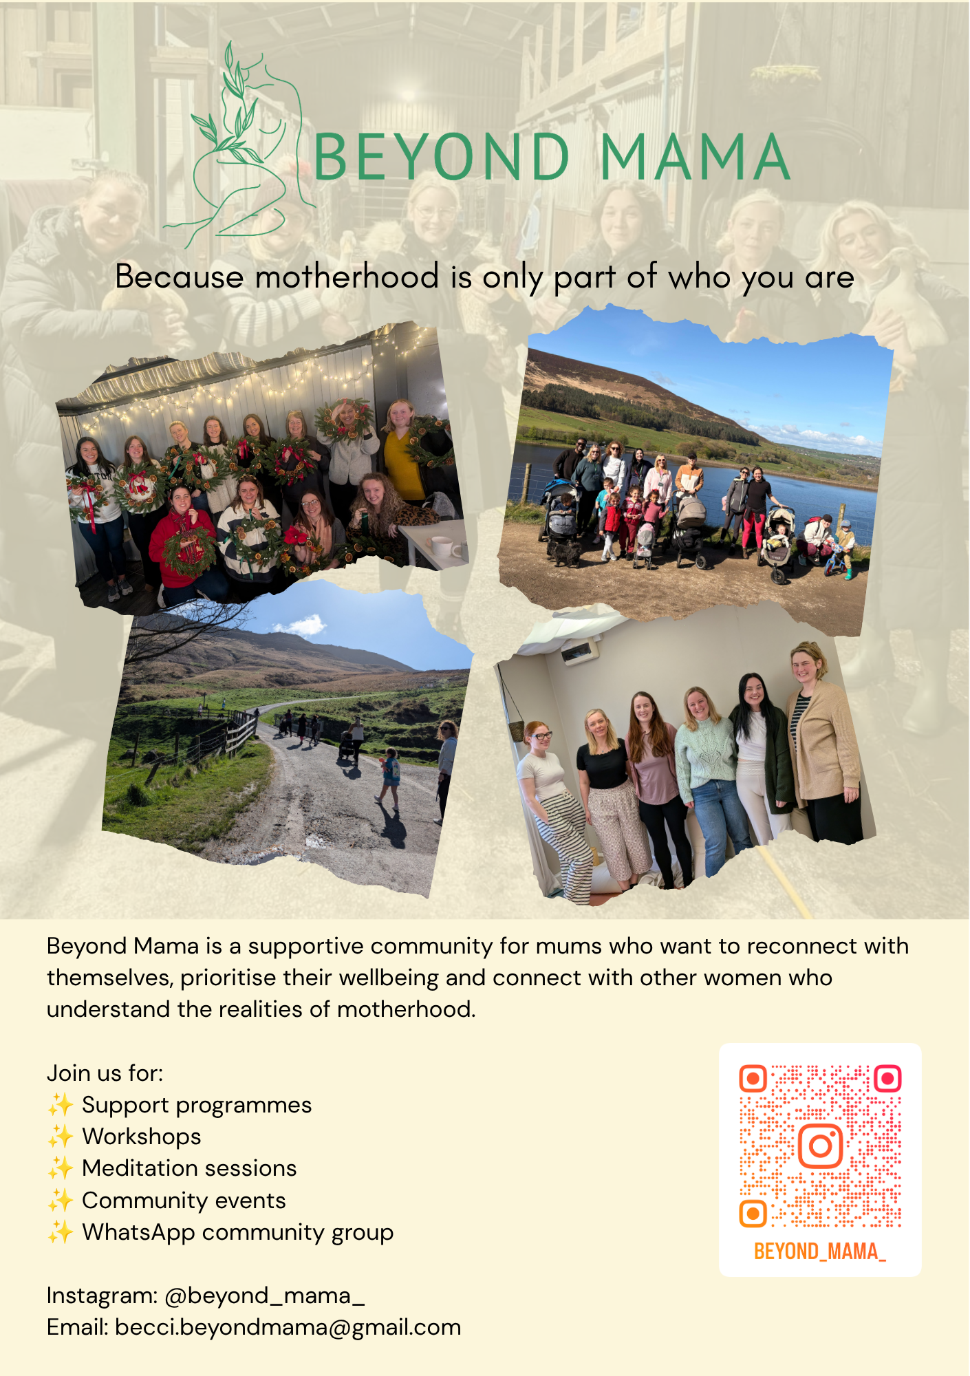

Kinder Giggles Newsletter

August 2026
Join us for outdoor fun and sports day games!
We will be holding stay and play sessions throughout the week, for all our parents to come and join us.
Babies Session – Monday 17th August 9.00am-10.00am
Toddlers Session – Tuesday 18th Augst 9.00am-10.00am
Pre-School’s Session – Thursday 20th Augst 9.30am-10.30am
Please let your child’s key worker know if you would like to attend.

Screen time guidance for under 5’s
Juggling family life and raising children in a digital world can be challenging.
Digital screens are a part of modern life, but finding the right balance between screen time and other activities for young children can be tricky.

How much screen time should my child have?
Limit total screen time for young children, wherever possible.

Under 2 years – Avoid screen time other than for shared activities with family that encourage bonding, interaction and conversation.
2-5 years – Try to keep it to 1 hour a day. Less if possible.
Young children’s brains are stimulated much more easily than an adult.
Find more information here; https://beststartinlife.gov.uk/screen-time-under-5s/
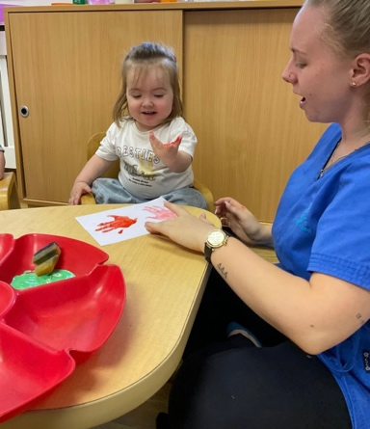
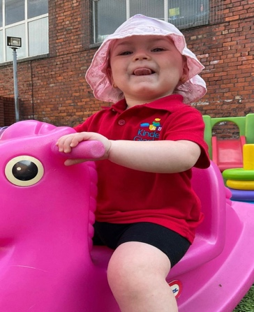
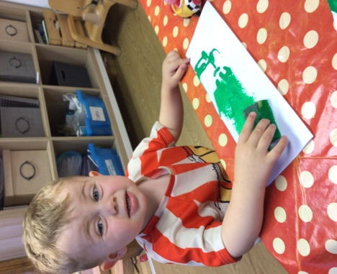

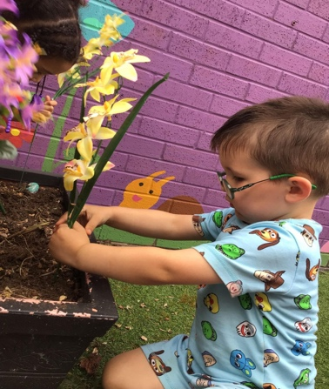
EMPLOYEE OF THE MONTH!
Our employee of the month for August is…

Jodie

Jodie always has a smile on her face and is very welcoming to everyone who comes into the Nursery.
She is always willing to help wherever she can and is a great support to the team.
Jodie also does a wonderful job of helping new parents feel comfortable, especially when it comes to their littles ones joining us for the first time!
Thank you for all your hard work and dedication!

August Dates
8th – Big Birthday! – Our Deputy Manager and SENDCO, Danielle turns 30!

12th – World Elephant Day – There’s no better way to celebrate world elephant day than dressing up as Elma! We would love the children to join us by wearing bright, patchwork coloured clothing as we learn all about elephants.

W/C 17th – Summer Stay & Play Week!

28th –Makaton Internation Awareness Day– This is a special opportunity to reflect on the power of communication, and the positive impact Makaton has on people’s lives around the world.

31st – Summer Bank Holiday– The Nursery will be closed.

Try this at home!
Have a go at this edible playdough activity!
All you need is:
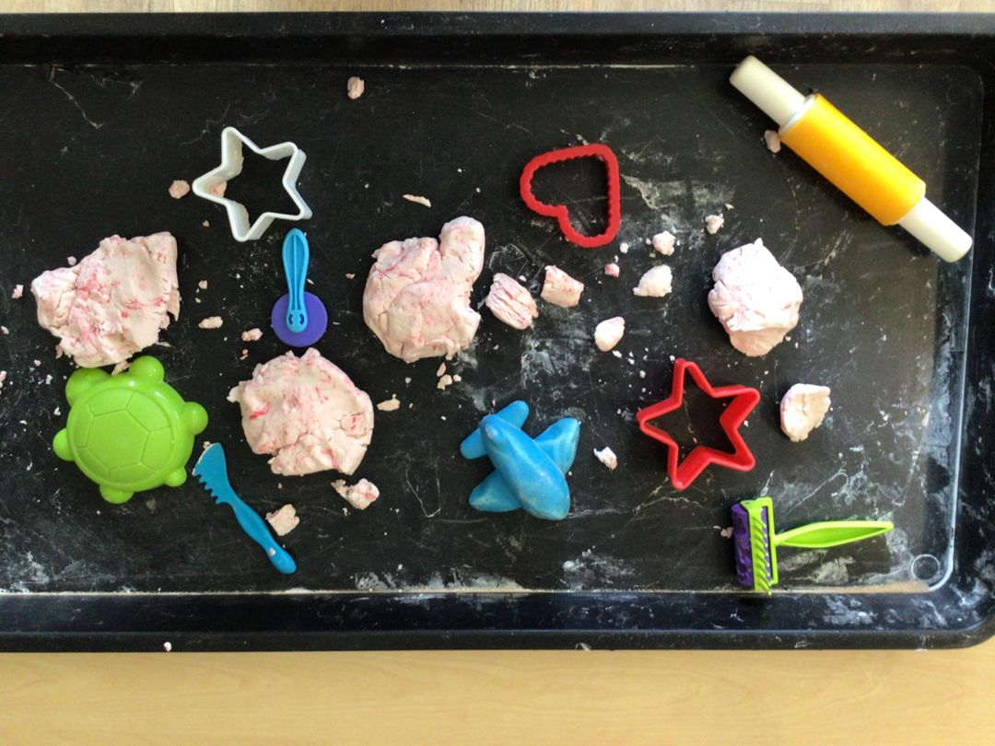
Corn flour & yoghurt for the playdough, a try and some playdough cutters.
This activity will allow your little on to explore different textures, helping to develop their fine motor skills and language, using single words such as, roll, squeeze and feel.

